Captain Samuel Stalnaker Heritage Society Newsletter
(Stalnaker Family Association)
Fall 2021
Website address: http://www.stalnakerfamilyassoc.org Editor: Elizabeth Parker

West Virginia Governor Justice Recognizes the
Captain Samuel Stalnaker Heritage Society
(The Stalnaker Family Association)
at the 2021 Annual Meeting and Reunion in Beverly, WV

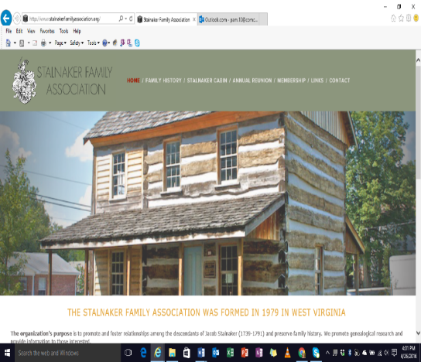
A Note from President-
Barry Stalnaker

During our 2021 Annual Meeting Lynn Phillips, a WV Governor’s Representative honored the Stalnakers for the endless efforts to preserve “our living history” in Beverly, West Virginia.
For 56 years the Stalnakers have gathered in Randolph County, WV to share our family history. They established the Stalnaker Family Association and adopted by-laws. They developed the family tree that goes back to the German Barons Samuel and Adam Stalnaker that arrived in Philadelphia, PA in 1727. The worked tirelessly to write the book, A Chronology of the Stalnaker Family in America that was published in 1982. Since 1994 the Stalnaker’s have worked to move, restore, and maintain the Jacob Stalnaker Cabin and the Old Stalnaker Cemetery. The cabin has been furnished with period correct items for all to see and touch. Many of the items are family pieces that are on loan to the cabin. The complete story of the cabin and its content are available from our Heritage Library. The name of the Association was changed to the Captain Samuel Stalnaker Heritage Society recently to acknowledge all Stalnakers. The new roster of family members that are buried in the Old Stalnaker Cemetery was published and distributed to reunion attendees. The cemetery contains individuals with the last names of Ball, Daniels, and Stalnaker.
Our Heritage Library has the complete story of the cabin and its contents available.

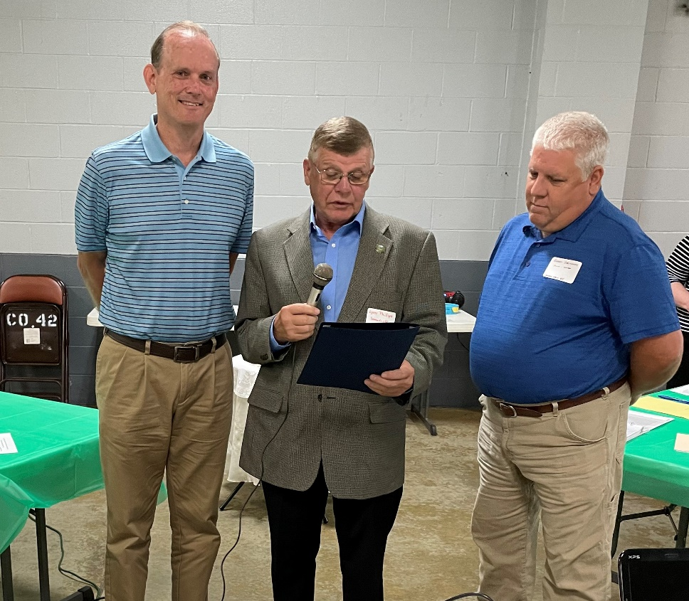

President Barry Stalnaker, Lynn Phillips, VP Robert Stalnaker

37 First Time Attendees to the Annual Meeting:
David and Mary Morrison of Savannah, GA
Shelby Stalnaker (6 weeks old) of Buckhannon, WV, Great Granddaughter of Anna Ruth Stalnaker
Bonnie and Bill Brockschmidt of Garnet Valley, PA
Linda and Frank Wetmore of Kent, Ohio
David and Karen Stalnaker Banko of Southgate, MI
Robert and Melinda Stalnaker of Mineral Wells, WV
Shirley Daniels of North Potomac, MD
Terri Daniels of Annapolis, MD
Pamela Stalnaker Lawson. EdD., of St. Albans, WV
Amy Lawson Hymes of St. Albans, WV
Beverly Stalnaker Bolles, PhD. of Dunbar, WV
Jimmy and Martha Stalnaker of Glen St. Mary, FL
Beverly Stalnaker Grant of Uniontown, OH
Bonnie and Steve Schow of Detroit, MI
Tami Faye Stalnaker-Richmond of Way, WA
Lisa de Gruyter of Clarksburg, WV
Robert Heller of Clarksburg, WV
Alyssa Cessna of Cumberland, MD
Paula and Brad Butler of Cumberland, MD
Mark Stalnaker of Frederick, MD
Alyssa Stalnaker Milborn and her husband and 7-month-old son of Vienna, WV
Jared Allman of Weston, WV
David and Janet Stalnaker of Beverly, WV
George D. Bragg of Craigsville, WV.
John Bragg of Webster Springs, WV
Carl C. Campien of Elkins WV

Welcomed the 3 Returning Relatives after a long absence:
Cub Stalnaker of Charleston, WV
Leah Stalnaker of Jumping Branch, WV
Bob Sponaugle of Elkins, WV, the son of late Past President Frankie Sponaugle

History Day 2021 was amazing!
It was so enjoyable due to the efforts of our cousins from Lancaster PA. Herbert Rinehart, husband of June Rinehart, made name tags with all attendees’s name and their Stalnaker line to wear. They used the Family Tree by Judge Cela Burge of Cape Charles, Virginia to identify ancestors. This really increased communications amongst cousins. Thanks to Herbert and June Rinehart.

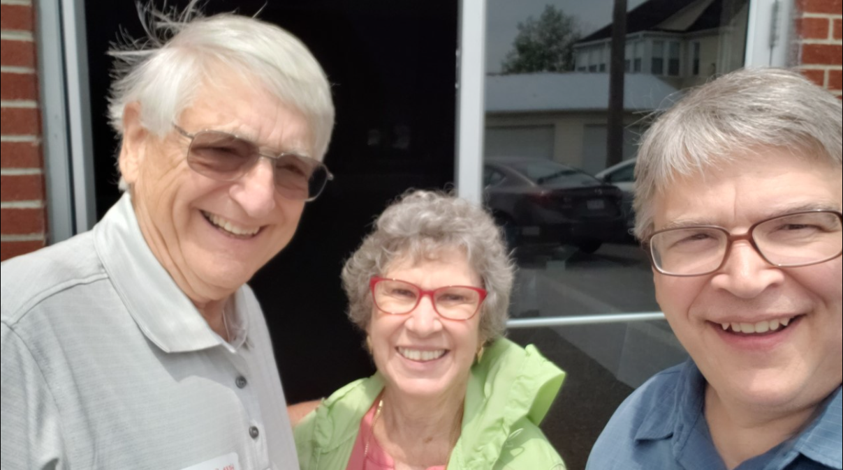

June & Herbert Reinhart and Brad Stalnaker

Note from Vice President—Robert Stalnaker
After the business meeting, a catered lunch by the Great Harvest Bread Company was enjoyed by all. All attendees were given the photo of the cabin and hearts and crosses from wood from the old Jacob Stalnaker cabin log made by our beloved President Bill Stalnaker before he passed
During the lunch break Dan Wilson presented the “Ghose of Benjamin Wilson, Revolutionary War Hero and neighbor of the Stalnakers”. He used many of our currency (quarters) to teach about impact of the Stalnakers in America. Terri Daniels did the summary of how Samuel came to America as a young man and his journey by time of the Revolutionary War.
The featured presentation was about the “Southern Stalnakers” that has taken many years of intense research for our President, Barry Stalnaker to develop. The slide show revealed where Samuel lived during his lifetime. It was a trip back in time. This is the first time that many of the Stalnakers learned about four children that survived the 1755 massacre. They were with their German Grandmother Stalnaker in the outbuildings. After the massacre, She took them to Frederick, MD for safety reasons. In the past it was known that Jacob survived but the other three children surviving is a miracle.
Now we are in the process of updating the book to include all the known descendants.
Please join Barry Stalnaker and Ashleigh Payton are working to get this project completed so all can enjoy learning about the Stalnakers. Barry is pleased to announce that the Stalnaker Group on Facebook has 1000 members.
The annual auction was a huge success with the grand item being a handmade “Jacob Ladder Quilt” made by the Stalnaker sisters, Pamela Lawson, and Beverly Bolles. The winner of the quilt was Beverly Baker of Reisterstown, MD.
Judy Dixon’s handmade items created the usual competition.

A Note from the Secretary- Sandy (Stalnaker) Wilson
Our 2020-2021 membership was 2020-2021 has 219 households in the Society.
An increase of 71 households over last year’s membership.
Currently our membership is only 149 households. We are down 70 memberships.
Membership is key to the survival of the Society.
This is a MUST, since the cabin and cemetery still had financial needs.
As a friendly reminder, I have put a red star on your Newsletter mailing label to mark that you have paid you 2022 dues. If you do not have a star by your name, please rejoin the Society.
Thank you to everyone that sent in their dues and generous donations to keep our “living history” alive in Beverly, West Virginia.
It has been great to see more cousins paying the annual membership dues for their special relatives and donations in memory of the beloved Stalnaker relative.
Consider giving a membership for the special Stalnaker relative that has a positive impact on your life.
As Mark Bowe of BARNWOOD BUILDERS said, “I have never seen a cabin in such great condition and is still in the hands of the original family”.
Please send your information for 2021 Brag Book to wilsondan@aol.com.

A Note from the Treasurer- Dan Wilson
The tax-exempt status of 501(c)(3) has had a positive impact on the generous donations from the Stalnaker cousins to the Society. A special letter is sent for each donation for the generous donor to use at tax preparation time. Our tax-exempt status is in the name of the Stalnaker Family Association.
Dues are used to support the History Day, Annual Meeting, and Reunion and for the publishing and mailings of the newsletters and Holiday Cards with Brag Book.
Generous donations are used for the maintenance of the cabin and cemetery.
We have established a permanent improvement fund (a memorial fund) for permanent improvements.
We have been very fortunate that one member donated $5000 to the Society in 2019.
We have had several relatives that passed away this year and the immediate relatives sent in monies in their memory their beloved Stalnaker relative.
We shared these donations at the 2021 reunion for all to see the impact of these donations.
The necessary tax forms have been filed with the State of WV (in August each year) and Federal Government (in January each year). The cemetery property taxes were paid.
All bills are paid after approval by the President using the approved budget. Since the Officers and Board of Directors donate all their time, every dollar goes directly to the maintenance of “Our Living History in America” in Beverly, WV. Our annual fundraiser is the Auction at the end of the reunion.
The handmade items by Pamela Stalnaker Lawson, Sandra Stalnaker Bolles, Judy Stalnaker Dixon, Cindy Reece, and Dennis Stalnaker were the top items. The Stalnaker Security Hats went quickly. We raised $
We currently applying to get credit card for members to pay their dues and purchase items from the Heritage Library.
Our current project is the Cemetery Head Stones Dedication that will be done in 2022 or later—demand for marble headstones is high at this time due to cov-19 deaths.
We voted to raise the dues to $15 per household in 2022 and to have a lifetime membership household status for $350

A Note on our Heritage Library – Ashleigh Payton
(Our Book Store) Ashleigh Payton and her father, Todd Payton monitored the printed materials this year at the reunion. The complete list of our heritage library materials contains research that was done by family members over the past 100 years and is available for the cost of the printing of the materials. Many of these materials have come from rare books in the hands of our family members like the Old Stalnaker Bible that Sandra Joy Moore of Parkersburg, WV just donated to the Society. The Harts of Randolph County by Lillian Hart was donated to the Association years ago by Debra (Booth) Bartell of Maquoketa, IA. The Hungry Mother’s State Park book has valuable information about what Judge Leo Stalnaker discovered while doing his research. This book was discovery by James Stalnaker of Bakersfield, CA in the 1990s.
This is a special service for members only.
The complete list of the Book Store materials was published in the Spring Newsletter that is on our website. We have learned that our materials are valuable. We must secure our research. As more information is secured, they will be added to the Heritage Library. This is an invaluable library and will be added to the updated book. We have been asked by many non-relative researchers to use our materials that are currently on the copyrighted website in their books. Our Past Presidents have denied the requests to make sure that our data is used accurately.

A Note from the Jacob Stalnaker Cabin Manager- Robert Stalnaker
I have made monthly inspections of the cabin and have overseen the monthly pest control treatments, the heating and cooling needs of the cabin, and the monitoring of the temperature readings in the log plus the visitations to the cabin.
RCHS is responsible to mowing the property, but they have only mowed it one time this year. Due to this neglect, there is a problem with mice in the cabin. We will be removing all precious items and securing them until this issue is resolved.
The roof needs to be replaced due to neglect (RCHS refused to let our employee power wash and restraint the cabin in 2016. We have been in negotiations with RCHS since 2016. The estimate to replace the roof is $22,000
We will need to fundraise for the replacement roof.
If you have fundraising ideas, please let Robert Stalnaker or Dan Wilson know. We own the cabin!
In 1995 there was a gentlemen’s handshake on responsibilities of the cabin.
Both Presidents are deceased and the new RCHS does not recognize the handshake agreement.
We have paid for everything except for the electricity to the cabin and the mowing of the grass since 1996. We offered in writing to purchase the land in August 2021, but RCHS does not want to sell the land. After negotiating since 2016 without success, we are in the process of getting legal assistance to move the cabin back to the original property by the cemetery.

To visit the cabin, submit a request through the Stalnaker Family Association Website Submission Form.
Barry Stalnaker communicates the request to me and I personally to arrange a tour of the cabin.

A Note from the Old Stalnaker Cemetery Manager- Delores (Stalnaker) Bragg
Our landscaper is doing a good job and the cemetery looks great during my weekly inspections.
Exciting news--Until now we did not know much about the cemetery and those buried in it.
There are 50 people buried in the cemetery and we plan to publish a book with the names and life stories of those buried in the cemetery. The roster is now available. The roster includes Ball, Daniels and Stalnaker family members.
Vice President Robert Stalnaker will be fixing the entrance to the cemetery this fall. The widening of the entrance will make it easy to find the cemetery and to assess the property.
The proper paperwork has been submitted to the US Government to obtain the Marble head stones for Jacob JR and Valentine. Valentine’s request was denied but we have found more information to submit. Valentine was denied but his widow resubmitted and got his pension. We have not heard about Jacob JR’s request. They are buried in the Old Stalnaker Cemetery where the road marker is located.

A Note from our Website Manager- Matthew Wilson
The website was totally updated over the 4th of July 2021 weekend. He is working to working on getting the newsletter posted on the website and so we can communicate timely information.
He will be updating the website soon with our current data on it. We hope to the credit card option available by December.

A Note from our Newsletter Editor & Facebook Jacob Stalnaker Cabin Manager- Elizabeth W. Parker
Elizabeth has done an outstanding job with the newsletter’s format, and we are so very appreciative of her commitment to the Society especially since she recently moved. She is amazing! She created the Jacob Stalnaker Cabin Facebook page and maintains it for everyone to enjoy.

“Brag Book” (Family Births) First Edition published in 2020.
Births will be announced in the December Holiday cards.
***Please send all births of Stalnaker over the past two years (2020-2021) to wilsondan@aol.com
It will be interesting to see all the last names that our Stalnaker cousins have.
Please include the name of the child, gender, date of birth, city, county, and state of the birth.
Please include the names of the proud parents, grandparents, and great grandparents (if know).
We would love pictures too and please label the pictures for us.
The annual deadline is Thanksgiving Day for new arrivals (births) to be published in the Brag Book.
The book will be printed and placed in the December Holiday cards.

We will be celebrating the lives of 56 relatives at the 2021 Reunion:
Anna Ruth Stalnaker lite the candle this year.

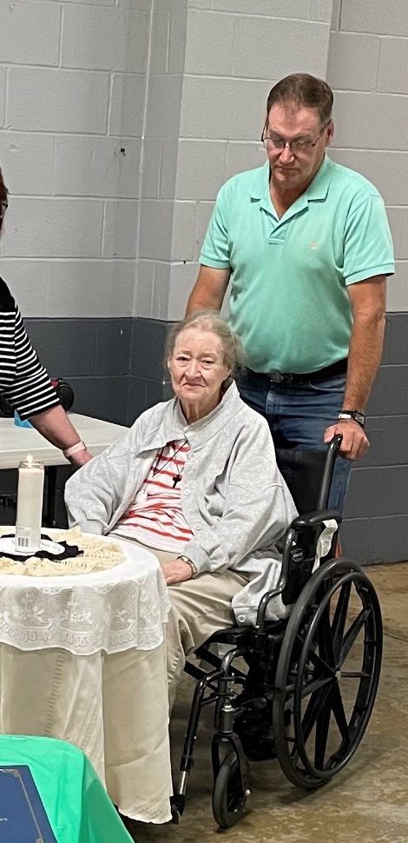

Anna Ruth Stalnaker & Son James
Current Officers and Board of Directors
Position- Name Term Location
President- Barry Stalnaker 2021-2023 Wilsonville, AL
Vice President- Robert Stalnaker 2021-2022 Mineral Wells, WV
2nd Vice President- Samuel Stalnaker 2021-2022 Buckhannon, WV
Secretary- Sandy (Stalnaker) Wilson 2021-2022 Novelty, OH
Treasurer- Dan Wilson 2021-2023 Novelty, OH
Co-Treasurer- Martha (Stalnaker) Litten 2021-2023 Lakeville, OH
Cabin Manager- Robert Stalnaker Mineral Wells, WV
Cemetery Manager- Delores (Stalnaker) Bragg Beverly, WV
Historian- Ashleigh Payton Milton, WV
Negotiator- VACANT
SFA Web Master- Matthew Wilson Owings Mills, MD
SFA Submission Officer- Barry Stalnaker Wilsonville, AL
Newsletter Editor- Elizabeth W. Parker Bridgeport, WV
Ladies Committee- Martha W. Burton Horner, WV
Looking for volunteer for position of negotiator for Society

Association website: Type this link to view historical documents:
http://stalnakerfamilyassoc.org/historical-documents/
Dues and Donations:
Annual dues time! Special thank you to everyone paid their dues already.
If you have not sent dues - good news - it’s never too late!

Remember with a generous donation to the cabin and cemetery maintenance fund – a special gift from the board will be sent to you. This year the donation gift is the Second in a Series of 4 notecards drawn by our cousin, Brad Stalnaker.
If you missed out on the first in the series, you could request the first set of notecards with an additional donation.
In the fifth year, the set will be one of each of the four notecards.
These notecards make wonderful gifts for a beloved relative or a friend.

Accomplishments of the Stalnaker Family Association over the past 55 years according to Bill Stalnaker’s Historian records (reprint because this is a must read)

Original Organizer, Odie Chapman is remembered for getting it all started with a family luncheon and discussion about our rich heritage and for the Old Stalnaker Cemetery Burial Information.
First President, Mrs. Paul (Winnifred) Scott is remembered for getting the Association organized.
Past President, Earl (Rusty) Stalnaker is for the First By-laws getting registered with the State of West Virginia, securing the 1750 Map Preservation and the ceremony restoration work for the 1976 Jacob Stalnaker SR monument to be placed in the cemetery that was donated by Judge Leo Stalnaker.
Past President, Cameron Stalnaker is remembered for the Chronology of Stalnakers in America book along with Cecil Stalnaker and Editor, Martin.
Past President, Frankie Stalnaker Sponaugle is remember for her fiscal skills to keep the Association established and the newsletter.
Past President, Ed Stalnaker is remembered for the saving the Cabin from being destroyed, Cabin Move, working the RCHS, website establishment and the working with WV Retired Teachers Association on the Cabin Restoration. Ed established a relationship with Hacker’s Creek Pioneer Descendants, Inc to house our old family records. Bill Stalnaker kept the originals for security reasons.
Past President, Madison “Rex” Stalnaker is remembered for the Road Marker, the first attempt to secure 501(c) (3) status with updated Bylaws, finishing the restoration, working with RCHS and for establishing the cemetery boundary lines with the help of Zane Stalnaker. He created the term “our living history” in America. The Jacob Stalnaker Facebook page was started under his leadership by Elizabeth Parker.
Past President, Pam Stalnaker is remembered for the Saving of the Cabin from the RCHS and the MOU attempts with RCHS. She got Barnwood Builders to come to feature the Cabin on the show.
Past President William Paul (Bill) Stalnaker is remember for keep our historical records in order, securing the 501(c) (3) status, updating our By Laws, securing our ownership of the Cabin, getting the cabin log corner repaired, participating in the Barnwood Builders shotting of the cabin, making the cabin handicapped accessible, getting the headstones and monuments for the Old Stalnaker Cemetery. Bill attended 55 reunions (1965-2021).
President, Barry Stalnaker has devoted considerable time to collecting research on the Stalnakers and he started the Facebook Page entitled the Stalnaker Family Group that has 1000 members in 2021.

There have been several other important relatives in the preservation of our history.
Charles Chapman, Judge Leo Stalnaker, Cecil Stalnaker, Martin Yokum, Marty Coffman, Marty (Stalnaker) Litten, Hazel Hankey, Wilmetta Hinkle, Peggy Harper, Joy Stalnaker DeFazio, Nancy (Stalnaker) Bundy, Ken Stalnaker, Judge Cela Burge, John Burdis, Sandy (Stalnaker) Wilson, Dan Wilson, Phillis (Stalnaker) Newell, Zane Stalnaker, Linda Stalnaker, Delores (Stalnaker) Bragg, Darrell Allman, Elizabeth Parker, Gregory Parker, Matthew Wilson, Martha Burton, Brad Stalnaker, Lacey Stalnaker, Nancy Jackson, Cindy Reese, Richard Jackson, Barry Stalnaker, James Stalnaker, Kevin Lloyd, Steven Stalnaker, Paul Scott, Icy Stalnaker, Eddie Stalnaker, MaryAnne Stalnaker and Anna Ruth Stalnaker.
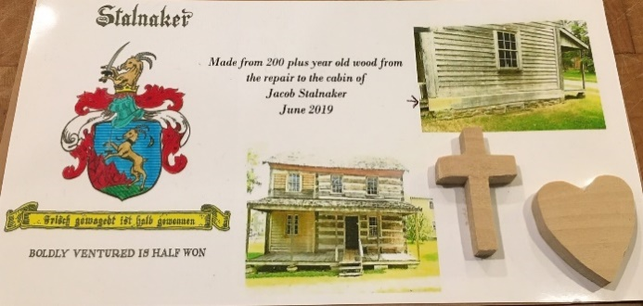
President, William “Bill” Stalnaker handcrafted and designed 130 crosses and hearts from a log extracted from the Jacob Stalnaker cabin for renovation and were distributed to those in attendance at the 2021 annual Stalnaker Family Reunion. Limit of one per person.
There are postcards available

Thank-you in advance for your support!

Remember your help is needed; just a few hours make a REAL DIFFERENCE!

Warm regards,
Elizabeth Parker, Editor

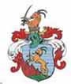
Welcome to the
Captain Samuel Stalnaker Heritage Society
(Stalnaker Family Association)
Website: http://www.stalnakerfamilyassoc.org
Please use this form when submitting your 2021-2022 dues and/or donating.
Mark the appropriate box(s) for any money you are sending to
The Stalnaker Family Association.
Please fill out the name and address section so we can keep you informed of the association events and happenings!

We appreciate you all & thank you for your continued support !

Name:

Address:

Phone #:

E-mail address:

Date of Birth: ____________________________Location:________________

Parents: ________________________________________________________

Wedding Date: __________________________Location: ________________ for the Holiday Card

Recent Births in your family:_________________________________________ for the Brag Book

Recent Deaths in your family:_______________________________________ for the Necrology Service

Select one – or – both when making an additional donation:

I am paying my 2021-2022 dues ($10.00)
Please pay dues by June 30, 2021

I am donating to the Society - amount of $
(Donations - used to support maintenance on the Stalnaker Cabin & Cemetery)

Please, return this form with dues / donations, make check payable to:
The Stalnaker Family Association
Treasurer: Dan Wilson
7700 Deerfoot Trail
Novelty, Ohio 44072

