Website address: http://www.stalnakerfamilyassoc.org Editor: Elizabeth Parker

The Stalnaker Family Association Annual History Day and Annual Meeting and Reunion for October have been cancelled due to Coronavirus-19.
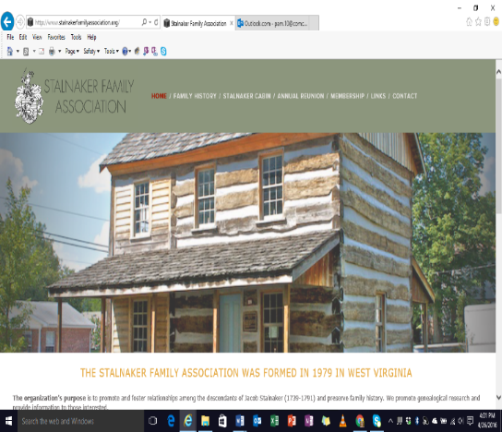
A note from President- William Paul “Bill” Stalnaker
I had worked to have the Saturday, October 24th History Day and the Sunday, October 25th Annual Meeting, Reunion and Auction. The hall was reserved and plans were made to have a cookout prepared by local merchants. The Stalnaker Quilt Show was organized to feature quilts made by Stalnaker relatives. The Cabin hearts and crosses made from the old log were ready to be distributed to each attendee.
The WV Governor, Justice was invited and we were waiting for his response. I was ready to send our invitation the Mayor of Beverly, WV. I was waiting to confirm the Governor’s visit before writing to the new Beverly WV Mayor.
Since there is still the 14 day quarantine in effect, I had to cancel the first ever Autumn Reunion.
Our 2021 History Day will be Saturday, July 17th at the Jacob Stalnaker Cabin with the Annual Meeting & Reunion will be on Sunday, July 18th.

A note from the Vice President- Barry Stalnaker
I will be the featured speaker at our 2021 Annual Meeting & Reunion.
I am pleased to announce the Ashleigh Payton of Milton, WV has accepted the position of Historian. We will begin the long process of working on the next edition of The Chronology of the Stalnakers in America.
The materials that have been submitted over the past 11 years to the association will be organized by Ashleigh
and we will be begin to write the book possibly in digital form.
We will need help from all Stalnaker relatives to make this project successful and correct.
Mark your calendars so you can join us for the 2021 events!

A note from the Secretary- Sandy (Stalnaker) Wilson
Our membership campaign for 2020-2021 has 149 households in the association. This is an increase of 17 households over last year’s membership. Due to coronavirus-19 we have had to work together to get all of our membership dues paid by mail. This is a MUST since the cabin and cemetery still have financial needs.
Thank you to everyone that sent in their dues already.
It has been great to see more cousins paying the annual membership dues for their special relatives.
We are able to get the newsletter to more relatives with these wonderful Acts of Kindness.
Consider giving a membership for the special Stalnaker relative that has a positive impact on your life.
Please join the association today.
Since the Officers and Board of Directors donate all their time, every dollar goes directly to the maintenance of “Our Living History in America” in Beverly, WV. As Mark Bowe of BARNWOOD BUILDERS said “I have never seen a cabin in such great condition and is still in the hands of the original family”. A special thanks to Elizabeth Parker for putting together the newsletters during this pandemic. We are very lucky to have her working for the Stalnaker Family Association.
Please send your information for next year’s necrology service to wilsondan@aol.com.

A note from the Treasurer- Dan Wilson
The tax exempt status of 501(c)(3) has had a positive impact on the generous donations from the Stalnaker cousins to the association.
A special letter is sent for each donation for the generous donor to use at tax preparation time.
Dues are used to support the History Day, Annual Meeting & Reunion and for the publishing and mailings of the newsletters and Holiday Cards.
Generous donations are used for the maintenance of the cabin and cemetery.
We have established a permanent improvement fund (a memorial fund). We have had several relatives pass this year and the immediate relatives sent in monies in their memory.
We will be sharing these donations at the 2021 reunion for all to see the impact of these donations.
***Our next project is to get a separate electrical meter for the cabin.
The necessary tax forms have been filed with the State of WV (in August each year) and Federal Government (in January each year). The cemetery property taxes were paid.
All bills are paid after approval by the President using the approved budget.

A note from the Jacob Stalnaker Cabin Manager- Darrell Allman
I have made monthly inspections of the cabin and I had the back door lock fixed. I have overseen the monthly pest control treatments, the heating and cooling needs of the cabin, and the monitoring of the temperature readings in the log plus the visitations to the cabin. RCHS mows the property.
All visitors must sign the guest book.
To visit the cabin, submit a request through the Stalnaker Family Association Website Submission Form.
Barry Stalnaker communicates the request to me and I personally to arrange a tour of the cabin.
During the Coronavirus-19 event, the cabin is closed and will remain closed to all visitors until the State of WV completely reopens.

A note from the Old Stalnaker Cemetery Manager- Delores (Stalnaker) Bragg
Our landscaper is doing a good job and the cemetery looks great during my weekly inspections.
Exciting news—We have just obtained the cemetery book written by Our First President, Odie Velta Nestor Chapman.
She worked on the book about Randolph County Cemetery Records entitled They Rest Quietly. She researched all cemeteries for 15 years and the book was published after her death. Her death occurred 268 years to the day (Sept 27, 1995) from the day that Captain Samuel and his brother, Adam Stalnaker landed in Philadelphia, PA.
Until now we did not know much about the cemetery and those buried in it. Now we have the information. There are 50 people buried in the cemetery and we will be publishing a book with the names and life stories of those buried in the cemetery.

A note from our Website Manager- Matthew Wilson
The website was totally updated over the 4th of July weekend.

A Thank You Note to our Newsletter Editor- Elizabeth W. Parker
Elizabeth has done an outstanding job with the newsletters and we are so very appreciative of her many talents. Her Spring 2020 Newsletter made our President Bill feel comfortable that all members were informed of the status of the association. Her efforts to communicate with the membership resulted in no one showing up for the cancelled History Day and Annual Meeting & Reunion.
Her efforts increased memberships and generous donations at the time when the association desperately needed them. Thank You!

Notable Events form the May 2020- September 2020:

Happy 60th Anniversary—President Bill Stalnaker and his lovely wife Anna Ruth celebrated their 60th wedding anniversary on July 1st and Cheryl’s Cookies were sent to them from all of the Stalnakers.
President Bill Stalnaker has finished all of his medical treatments for a rare type of cancer as of Sept 1st.
He is weak but his spirits and dedication to the association is strong. He tried so very hard to have an Autumn reunion. His perfect reunion attendance is still intact. Bill will see everyone next July.

Announcement –Proud Grandparents
We are pleased to announce that Darrell and Beth Allman have a one year old grandson that lives in WY.
Darrell and Beth will be moving to Wyoming to be closer to their only grandchild.
They hope to relocate in Wyoming by next spring.
***Darrell will be working to get the electric meter installed as his last project for the association.
We have been so blessed to have Darrell doing this job. He will be hard to replace. We wish them the very best in Wyoming with their daughter and grandson.As soon as they have a new address we will share with everyone.

New “Brag Book” (Stalnaker Family Association Births)
Births will be announced in the December Holiday cards.
Please send all births of Stalnaker over the past two years (2019-2021) to wilsondan@aol.com
It will be interesting to see all the last names that our Stalnaker cousins have.
Please include the name of the child, gender, date of birth, city, county and state of the birth.
Please include the names of the proud parents, grandparents and great grandparents (if know).
We would love pictures too.
The deadline will be November 30th for this year’s new arrivals list.
The book will be printed annually and placed in the December Holiday cards.

Updated Deaths since the Spring Newsletter:
*Alice Smith, 100 years old of Hartford Village, Vermont passed in 2007
Her education career lasted for 50 years. She was a teacher and principal.
*Eva Anderson, 88 years old, of Dunbar, WV., passed April 18, 2012.
Mother of *Sandra Stalnaker Lawson, PhD of St. Albans, WV. and
*Beverly Stalnaker Bolles, EdD., of Dunbar, WV.
Howard “Ike” Burton Moore, 90 years old of Huntsville, AL passed April 19, 2018.
Helmut “Hal” Schreiber, MD, 75 years old of Shaker Heights, Ohio passed in July 2, 2018
He was related to Captain Samuel Stalnaker’s mother.
*Helen M. Ingram, 91 years old of Apple Valley, CA., passed April 30, 2019
Pheba V. Hoffman Arbogost,
Sister of *Doris Baker
Leulla E. Hart, 92 years old of Elkins, WV. passed January 18, 2020 (husband died in 2003)
Mother of * Calvin Hart of Elkins, WV.
Robert A. Stalnaker, 68 years old of Gassaway, WV. passed on March 26, 2019
*Leslie E. Cox, 84 years old of Beckley, WV. passed April 25, 2020.
Husband of * Lena Stalnaker Cox
*Vilas Dale Stalnaker, 95 years old of Elkins, WV. passed on May 5, 2020
Uncle of *Charles L. Hight of Hedgeville, WV.
Albert Glen “Butch” Stalnaker, 72 years old of Marietta, Ohio passed August 5, 2020

*denotes active member of the Stalnaker Family Association

Current Officers and Board of Directors
Position- Name Term Location
President- William Paul “Bill” Stalnaker 2019-2021 Buckhannon, WV
Vice President- Barry Stalnaker 2019-2021 Wilsonville, AL
2nd Vice President- VACANT
Secretary- Sandy (Stalnaker) Wilson 2018-2021 Novelty, OH
Treasurer- Dan Wilson 2019-2021 Novelty, OH
Co-Treasurer- Martha (Stalnaker) Litten 2019-2021 Lakeville, OH
Cabin Manager- Darrell Allman Weston, WV
Cemetery Manager- Delores (Stalnaker) Bragg Beverly, WV
Historian- Ashleigh Payton Milton, WV
Negotiator- VACANT
SFA Web Master- Matthew Wilson Owings Mills, MD
SFA Submission Officer- Barry Stalnaker Wilsonville, AL
Newsletter Editor- Elizabeth W. Parker Bridgeport, WV
Ladies Committee- Martha W. Burton Horner, WV
Looking for volunteers for the positions of 2nd VP and Negotiator
2020 Elections will be for all four positions due to Coronavirus-19

Association website: Type this link to view historical documents:
http://stalnakerfamilyassoc.org/historical-documents/
Dues and Donations:

Annual dues time! Special thank you to everyone paid their dues already.
If you have not sent dues - good news - it’s never too late!
Remember with a generous donation to the cabin and cemetery maintenance fund – a special gift from the board will be sent.
This year the donation gift is the First in a Series of 4 notecards drawn by our cousin, Brad Stalnaker.

Enclosed is the membership form for your convenience to submit your annual dues.
We need and appreciate your continued support to maintain and grow the success of our association.

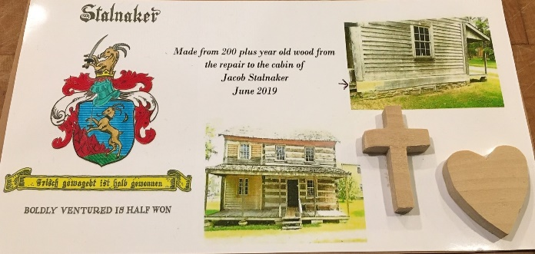
President, William “Bill” Stalnaker handcrafted and designed 130 crosses and hearts from a log extracted from the Jacob Stalnaker cabin for renovation and will be distributed to those in attendance at the 2021 annual Stalnaker Family Reunion. Limit of one per person.

Thank-you in advance for your support!

Remember your help is needed; just a few hours make a REAL DIFFERENCE!

Warm regards,
Elizabeth Parker, Editor

